TAMPILAN UI - DASHBOARD
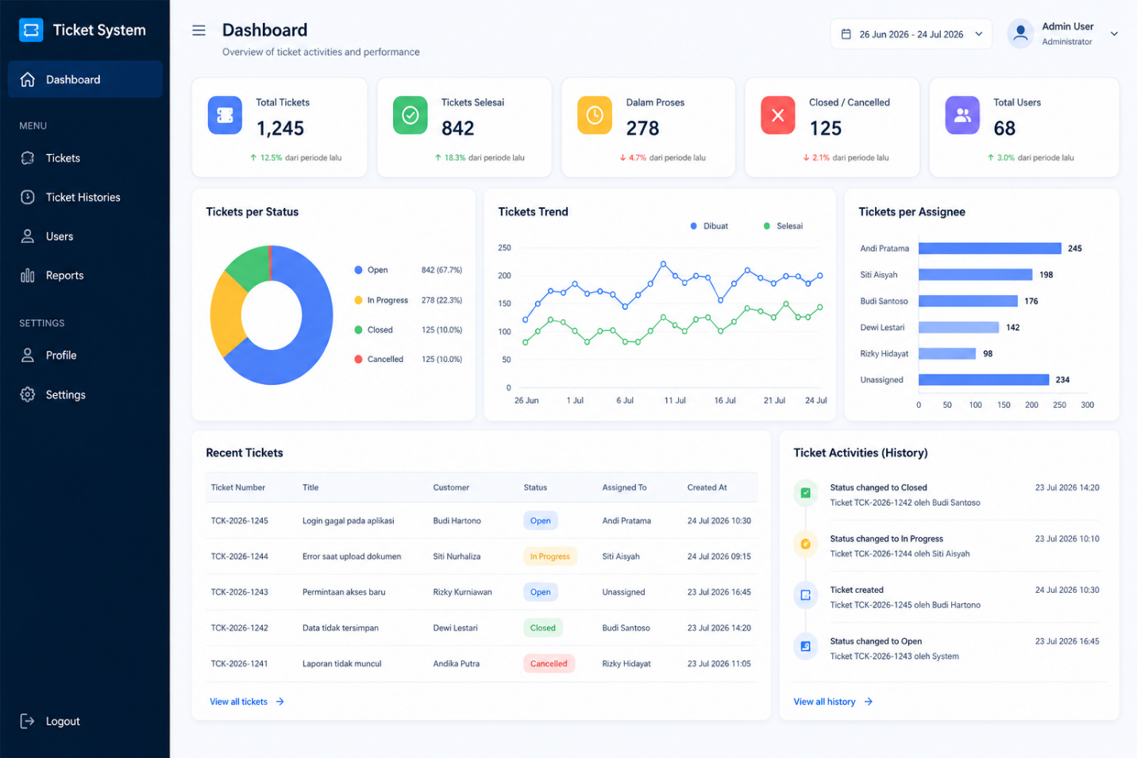

TAMPILAN UI – TICKETS LIST (FADLIH)
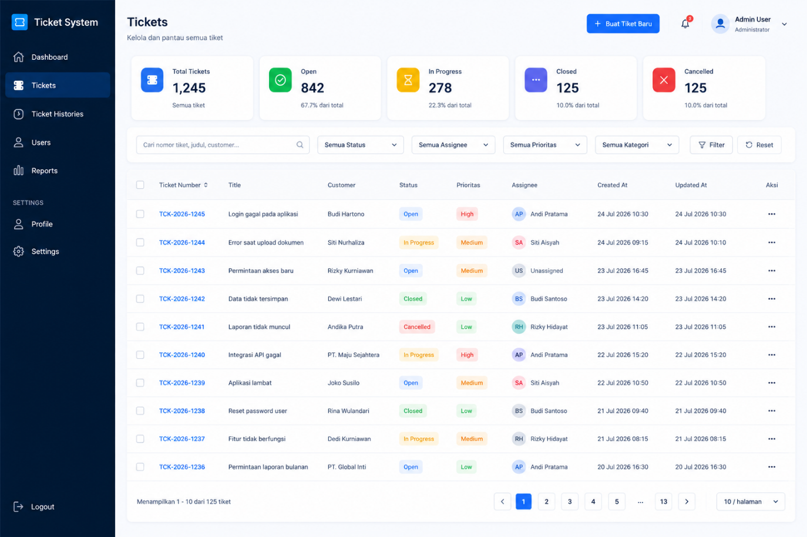

TAMPILAN UI – BUAT TIKET BARU (YASIR)
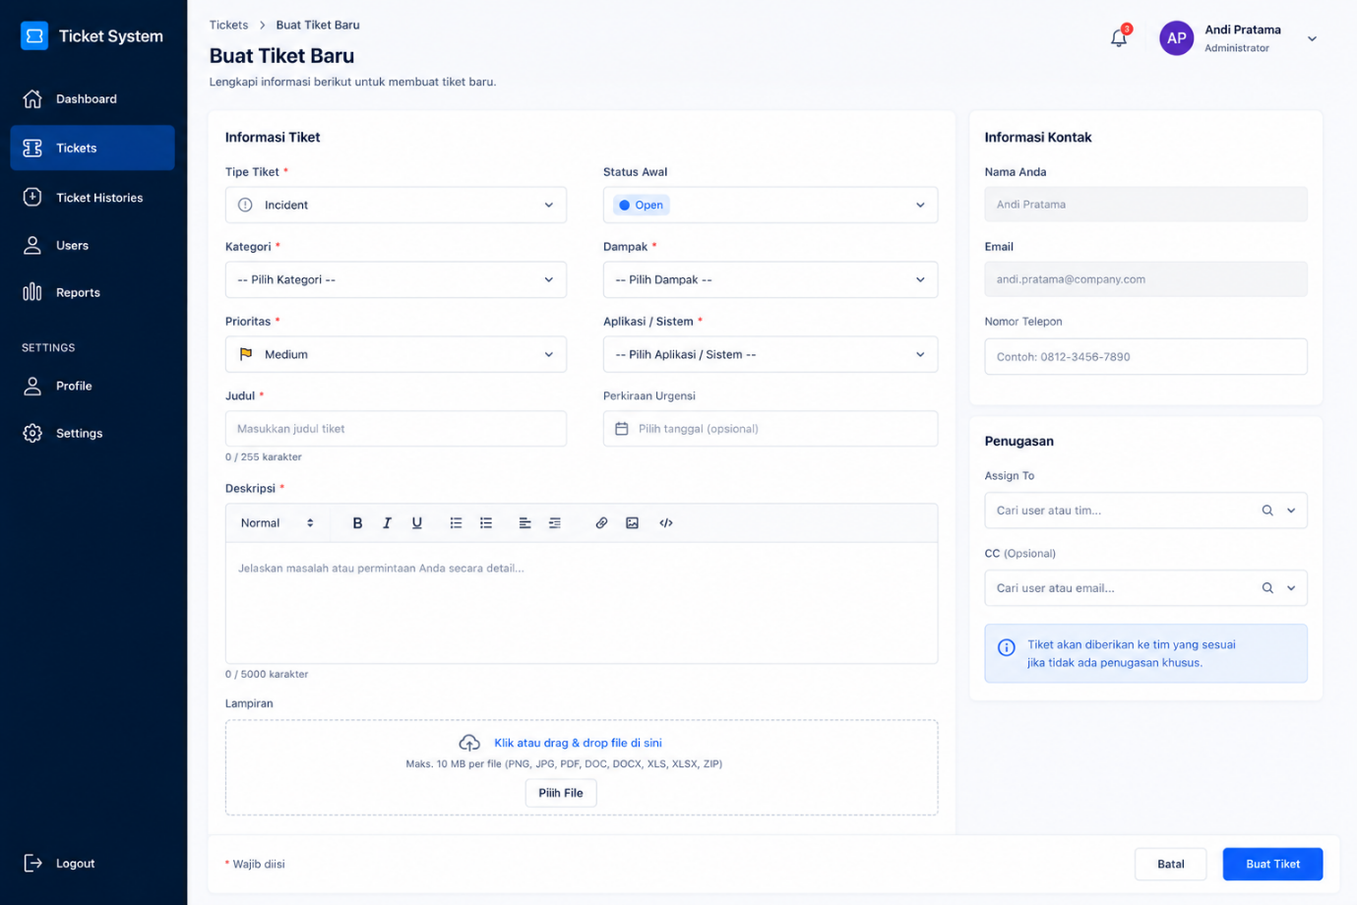
TAMPILAN UI – UPDATE TIKET (YASIR)
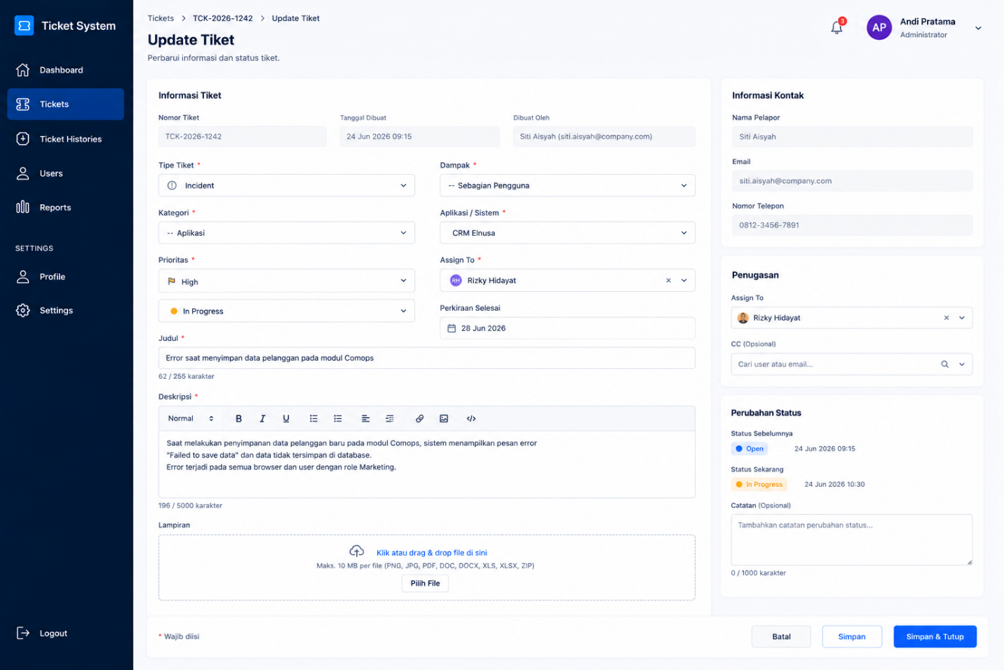

TAMPILAN UI - TICKET HISTORIES (BONDAN)
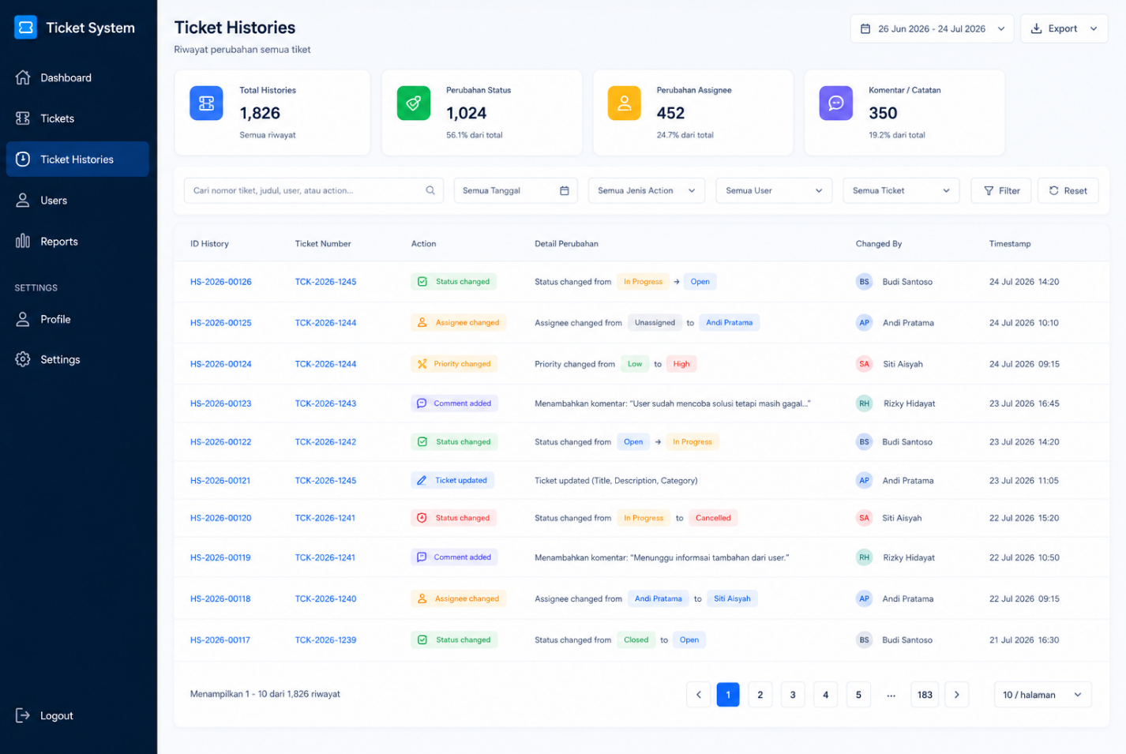

TAMPILAN UI - USERS
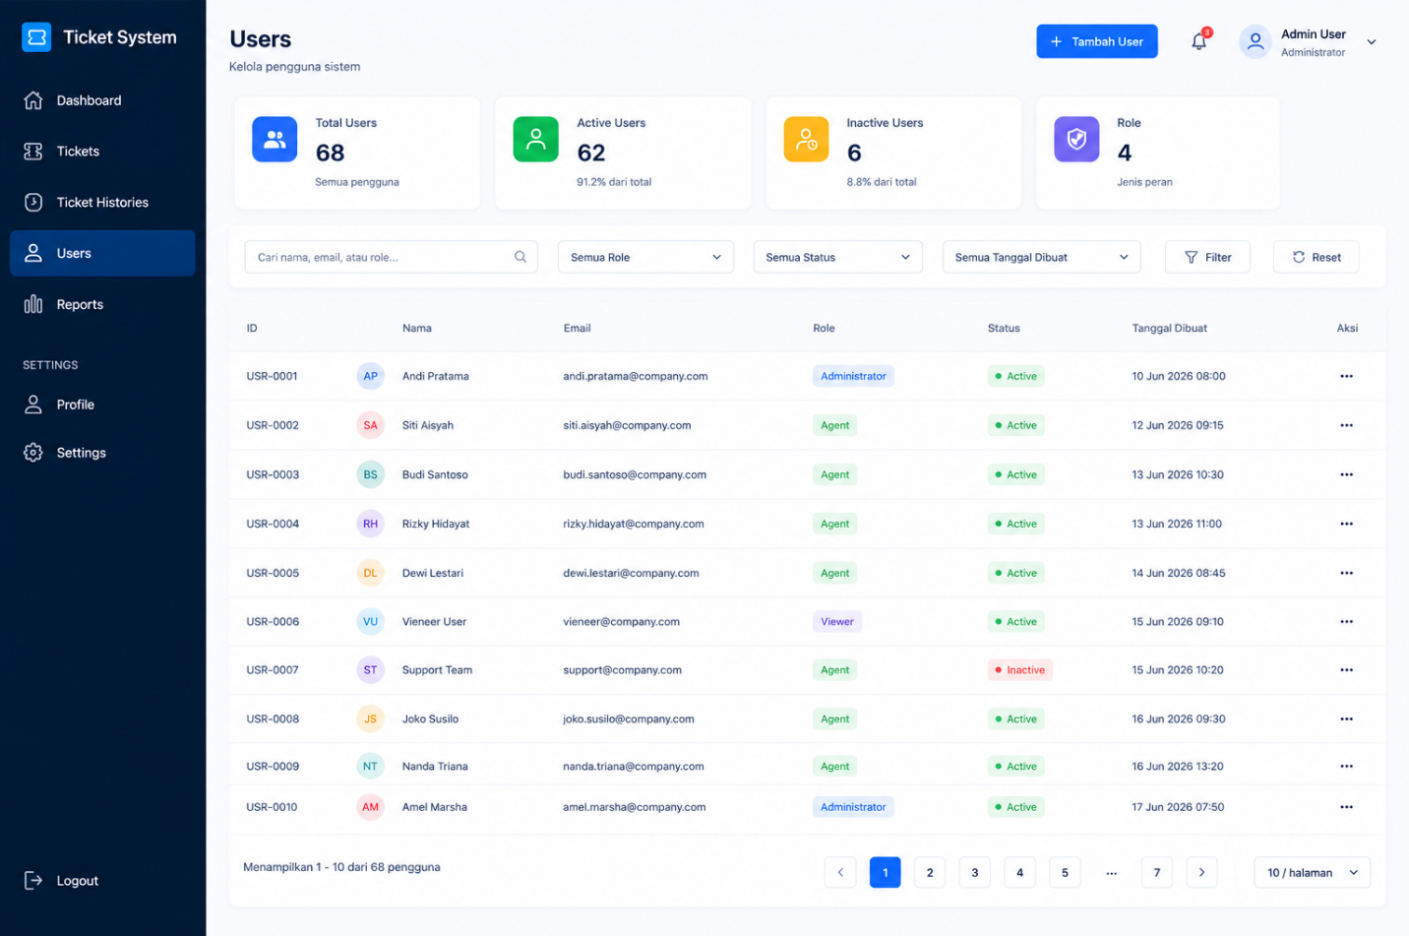

TAMPILAN UI – REPORTS (TIM)
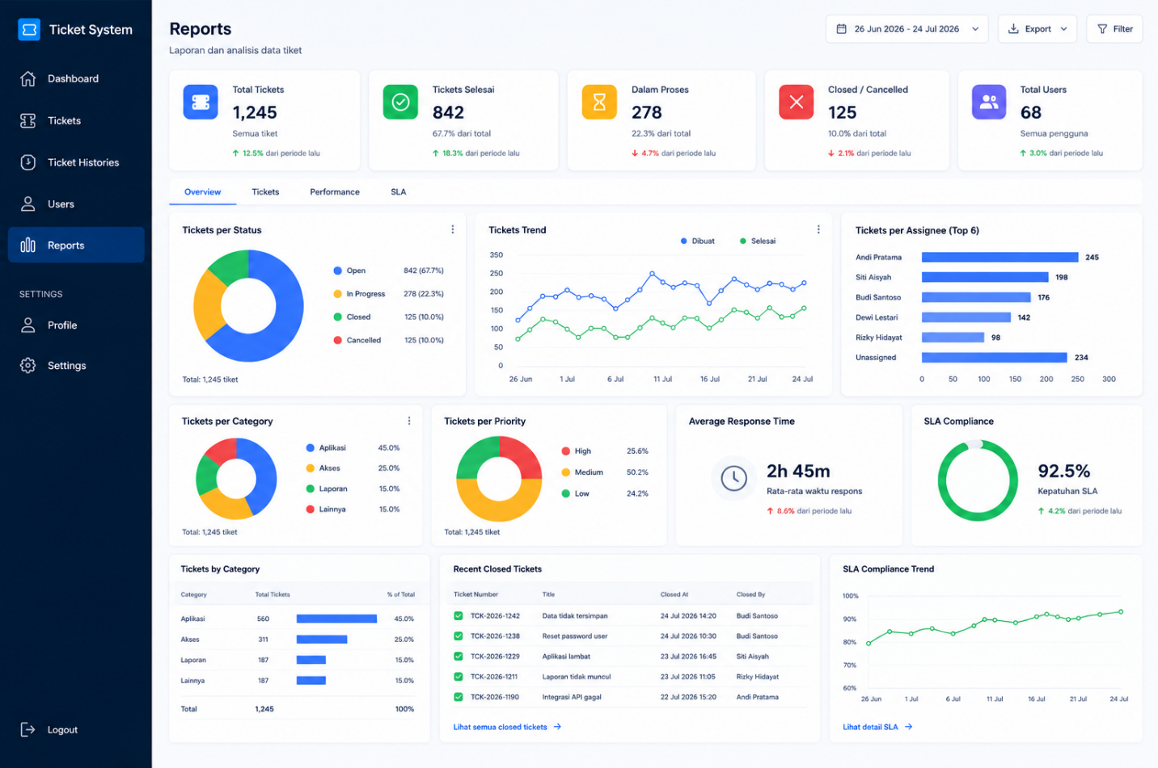

TAMPILAN UI - PROFILE
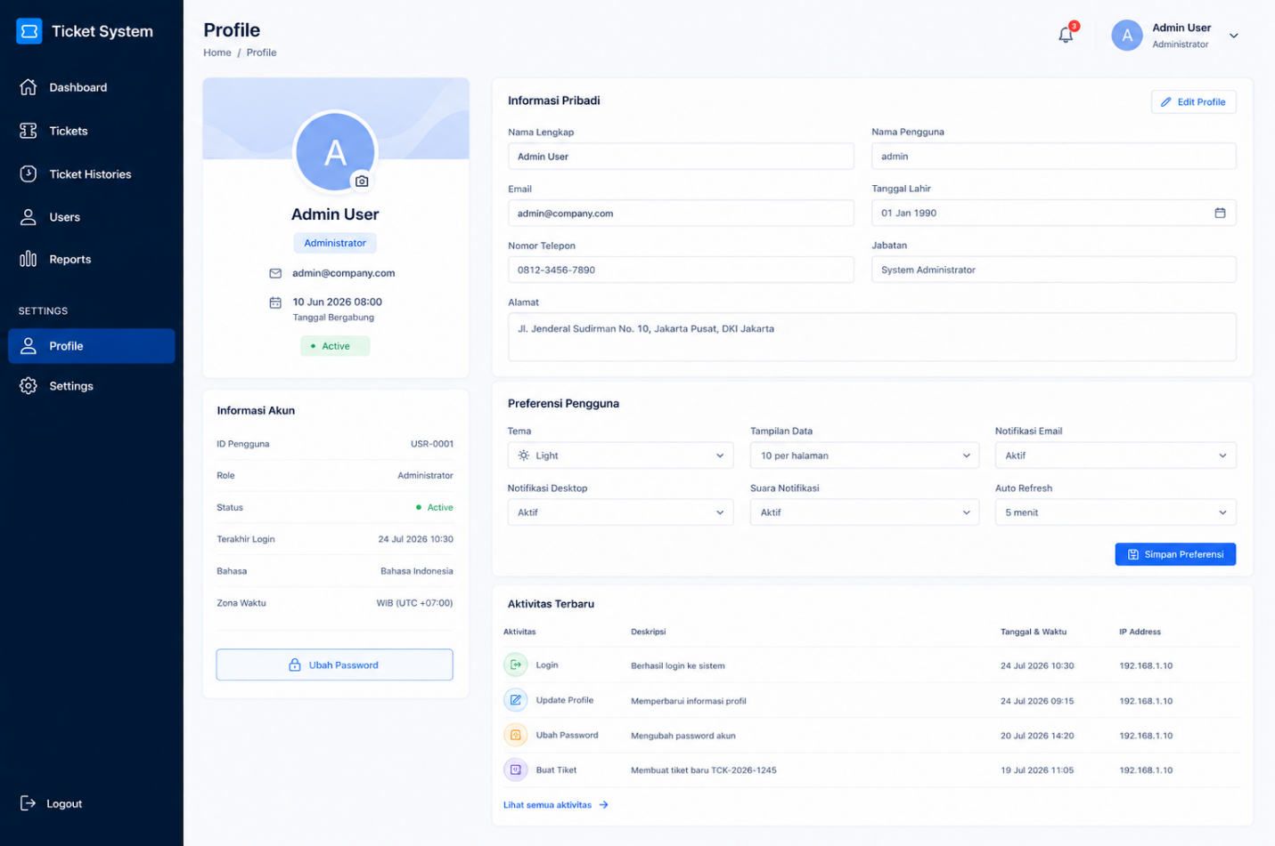

TAMPILAN UI - SETTINGS
